**Electronically Steerable Catheter**

Zane Johnson, Tanner Karbonik, Erin McFadden, Michael Pass, Matt Situmeang  
University of Iowa, Biomedical Engineering Department  
BME:4910 Biomedical Engineering Senior Design

zane-johnson@uiowa.edu, 715-513-0253  
tanner-karbonik@uiowa.edu, 630-631-9927  
erin-mcfadden@uiowa.edu, 319-240-6463  
michael-pass@uiowa.edu, 641-330-9162  
matthew-situmeang@uiowa.edu, 319-217-9191

**Background**

Heart disease is the leading cause of death in the United States and is responsible for nearly one in four deaths, accounting for over 600,000 each year [1]. Cardiac catheterization is commonly used for both diagnosis and treatment of heart disease. For these procedures, surgeons navigate a hollow tube (catheter) through a patient’s blood vessels as a minimally invasive treatment option. Although these surgeries have lower associated risk than fully invasive procedures, complication risk grows appreciably as surgery time increases [2]. Our goal is to develop a novel method to improve the usability and actuation of steerable catheters to increase surgical accuracy and decrease procedure times.

Currently, there are two general types of steerable catheters: handheld mechanical actuation and automated robotic actuation. Handheld devices may be cumbersome and awkward to work with, sometimes requiring two hands to operate, thus leading to increased procedural time. Robotic catheters cost millions of dollars, decreasing accessibility. This device aims to bridge the gap to give surgeons greater ease of use and accuracy at a lower cost all while improving patient outcomes by implementing electronic handheld control.

**Prior Art**

Our design combines handheld and electronic capabilities making it unique to the medical catheter market. Many products use either electronic steering on a larger robotic device or use purely mechanical actuation on a handheld catheter. By combining aspects of both types of devices, we hope to find a unique niche in the medical field.

Current handheld catheters, such as JP 4194691 B2 2008.12.10 [3] and EP 0 634 941 B1 (Figure 1) [4], use multiple pull-wires to actuate the distal tip of the catheter. These designs can actuate in multiple planes which is desired for our design. These devices are limited by their use of multiple mechanisms to move the tip in different planes. Furthermore, they can require the use of multiple hands to operate which is undesirable for surgeons. Our device works to improve the control mechanism by creating an electronic d-pad to operate the device in multiple planes with a single, one-handed controller, differing from existing solutions to multiplanar motion. Although the mechanisms are similar, the control system of the mechanisms is novel in our design.

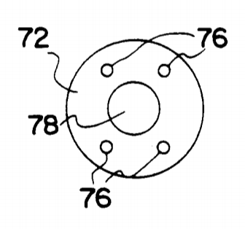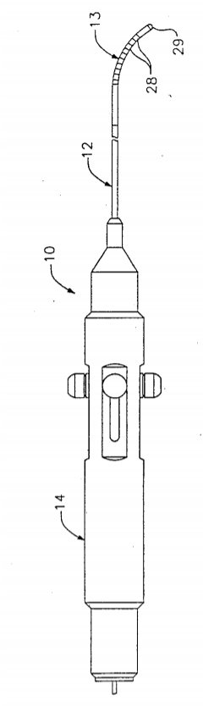

Figure 1: Handheld catheter designs from patents

Robotic catheters achieve the goal of electronic controls, but their use is limited by their cost and size. Designs like US 2018 / 0055589 A1[5] and US 2018 / 0132950 A1 [6] (Figure 2) require a dedicated computer workstation to perform surgery. These stations are large and expensive which restricts surgeons’ access to them. The device itself is also costly. Hansen Medical’s Magellan Robotic System costs between 1.2 and 1.5 million dollars [7].

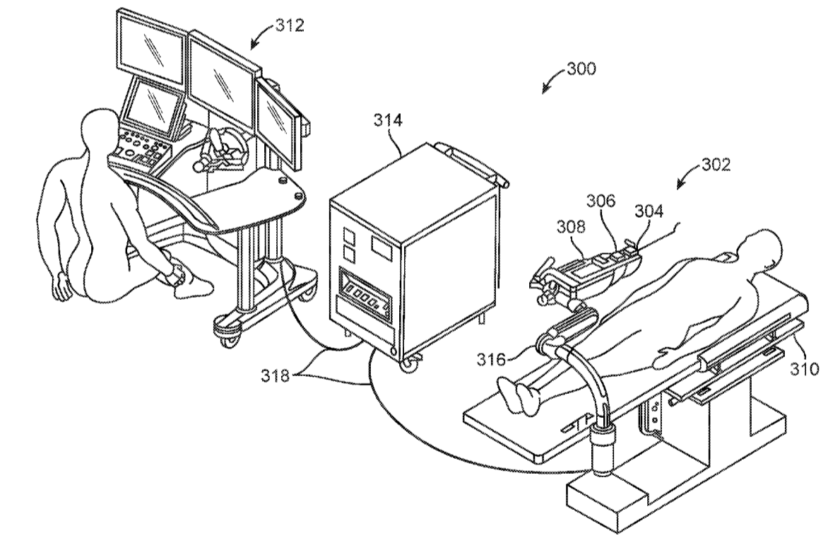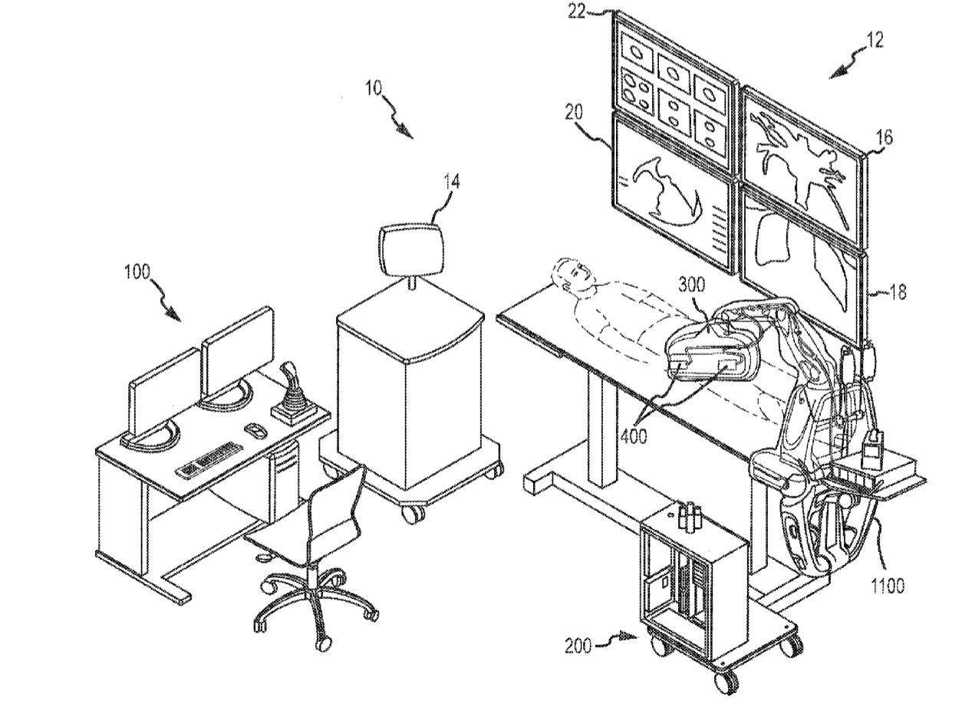

Figure 2: Patent art for robotic catheter designs

**Project Narrative**

The project started with gathering information from the end users. An interview was conducted with three physicians at the Iowa Heart Center at Mercy Hospital. Through this interview, we learned some of their concerns as surgeons. They were worried about the cost of the catheters initially. They mentioned that, as doctors, they don’t mind the cost, but hospitals will not purchase new technology if it does not prove to be effective at a certain cost range. Another concern they had was procedural time. They had been using guide wires that they bend by hand, insert, and test. If the bend was not appropriate for the vasculature, they would have to remove the wire, bend it to better fit, and try again. This was time consuming for them and they wanted a better solution that was easier to use. Through this information and from resources online, we developed our functional requirements.

The first functional requirement is that the device must be affordable. No matter the quality of the device, if it cannot compete with existing designs in the market, the product will fail. The price that the group will be aiming for is less than $500 per device. The second requirement is that the device must be waterproof. The risk of electric shock is high with an electronic device in a potentially aqueous environment. The device would have to be tested according to the IEC 60529 IPX7 standard which includes being able to submerge the device one meter underwater for 30 minutes. Another requirement of the device is that it must be sterile from manufacturing until use. This is important for reducing the risk of infection during and after a surgery. The catheter must also comply with ISO Standard 11737-2:2009 to be respected.

Another important feature is having the catheter contour to the varying desired turns and angles, therefore the surgical area can be reached easier. It’s difficult to maneuver through the vasculature, so it is imperative that the actuation of the catheter is precise in the means of not damaging any cardiac structures, ensuring our design complies with ISO 20993 – Biological Evaluation of Medical Devices.

Although each functional requirement is important to the success of the device, three were identified as crucial. These key modules dictated the design approach that was taken. Each was specifically chosen in order to satisfy the objectives of the project in a succinct and strategic matter. The first is that it must be electronically controlled. Because this was the whole premise behind the project, it was deemed the most critical module. In order to complete this module, mechanical actuation first needed to be achieved. This was simply done by placing a tube of less stiffness inside of a more stiff material and attaching a wire. Next, the force needed to actuate the tip was measured, and the components for the electronic actuation were selected. Stepper motors (see Appendix D) were chosen for their low profile and high torque. These would ensure that all of the components could fit into a compact handle as well as provide the specifications required. While components were being selected, the bread board and wiring of the system was designed. Several iterations were made on this process until all necessary parts were put together to create a circuit board that would allow for precise control of the motors with the inclusion of standard safety features (Figure 3). This diagram was initially designed to accommodate six motors for future designs, but will only utilize two motors for the current prototype. Every part of the circuit design was documented to allow for further iterations and to be used for a printed circuit board (PCB) for a wireless catheter.

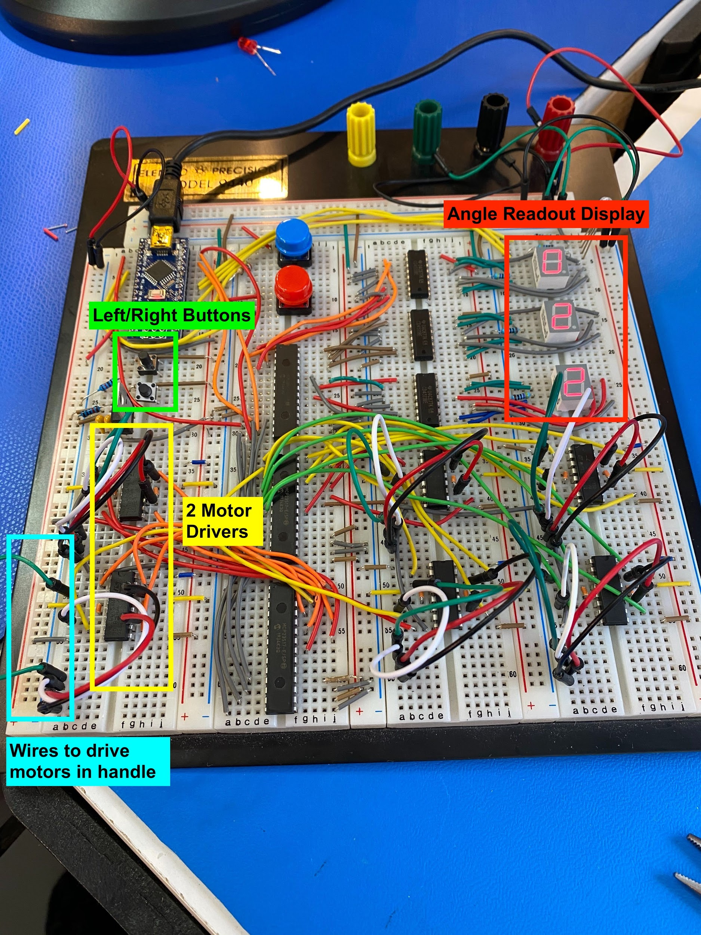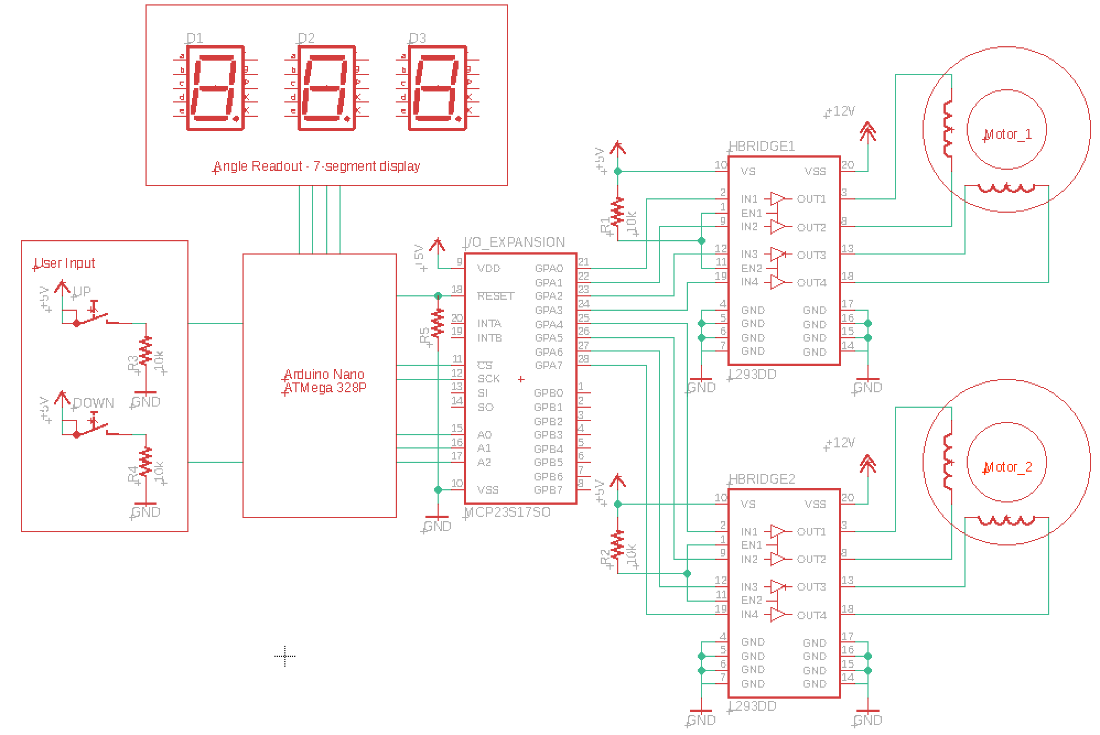

Figure 3: Top down picture of circuit board. Diagram of an initial circuit.

The second key module was the handle design. When designing the handle, there were several key requirements that needed to be considered. The most prominent were electronic actuation, one handed use, and waterproof ability. Due to the nature of the project, these were vital to the success of this device in the market. To begin, the motors and electronics needed to actuate the catheter tip were selected. These governed the overall size that was required in order to include all the needed components. The next step was making the contours of the handle comfortable and safe for the user. Molding materials such as clay and styrofoam were used as well as consulting other comfortable hand-held objects. These were crucial for getting the curves and placement of components correct. Lastly, waterproof ability was considered. The handle was designed with interlocking ridges in order to stop leaks as well as screws located strategically on the handle for maximum security. Furthermore, silicone, rubber or some other materials were being looked into for a more complete sealing of the handle.

The final key module was power delivery. In order to operate the electronic system and keep the desired handle size, the design needed an electronic power system that had enough power to drive the motors safely while still fitting within the size constraints. An initial design using a twelve volt wall power cable provided sufficient power to create the necessary motor torque. The final prototype could have continued to use this system after undergoing additional testing to assure safety from electrical shock and excess heat distribution. Considerations into a fully battery powered catheter were made, but were deemed unnecessary after consulting with experienced catheter engineers. A cord powered catheters would be considered marketable and safe, so the switch to battery power was saved for future design iterations.

The initial goals of the device design, aside from the functional requirements, were to have multiplane actuation and a battery power delivery system. Multiplane actuation would have been a huge undertaking and would have required twice as many pull wires, and therefore, twice as many motors. This increases the complexity of the physical and electronic design, but the technology could have been used for several more procedures and increase the ease of use. Through this development, some design changes might have been made including a different mechanism for pulling wires that is more space efficient. The battery power delivery system also would have been a large task to accomplish. This would have created several similar problems in the process similar to those created by multiplane actuation. Housing the batteries in the handle would have been difficult for space management, but also the balance due to the weight distribution of the device would have to be considered. These loftier goals were not reached partially due to the COVID-19 outbreak limiting our ability to continue designing and prototyping.

Slightly before the pandemic outbreak, we had the opportunity to visit Medical Murray to work with professional R&D engineers to manufacture a catheter. During this visit, several hours were spent learning about the process of making steerable catheters. Through this, a prototype was manufactured using materials provided in the R&D lab. The end product of this visit was a bidirectional steerable catheter that was ultimately used for the final prototype.

**Final Design**

The final design can be seen in Figure 4. It features the contoured handle design, the angle controlling d-pad, strain relief, and the extrusion. All of these were placed together with a tight tolerance to avoid leaks and maximize space.

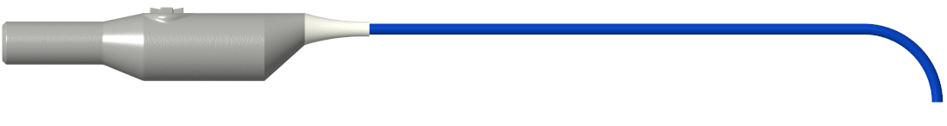

Figure 4: Side view of final design. Steerable catheter extrusion shown in blue, strain relief shown in white, and handle shown in grey.

Inside of the handle, as seen in Figure 5, the motors and strain relief mounts were designed into the handle to minimize space used as well as to secure the two halves together efficiently. The motors were placed in opposing directions in order to keep the pull wires from tangling and redirecting pegs (seen by the colored circles in Figure 5) were placed to keep the pull wires separated. The extra space at the back end of the handle is for further development in order to place the printed circuit board, batteries, and wiring into the handle.

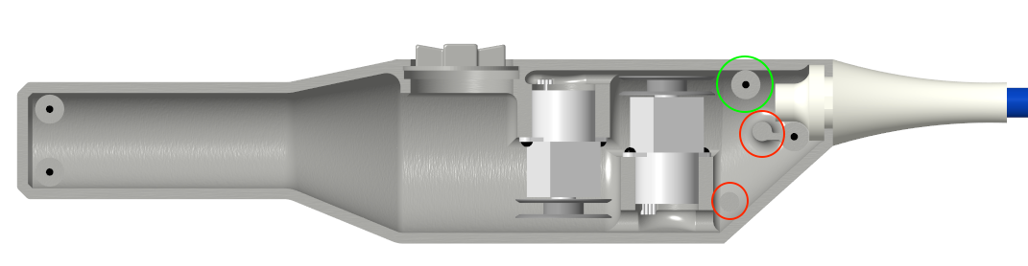

Figure 5: Internal side view of handle with wire redirecting pegs highlighted. The top wire peg is circled in green and lower pull wire pegs are circled in red.

The interlocking ridge design can be seen clearly in Figure 6. In addition, the pegs have two roles, one as the redirection of the wires as stated previously, but also to ensure the two halves of the handle align properly.

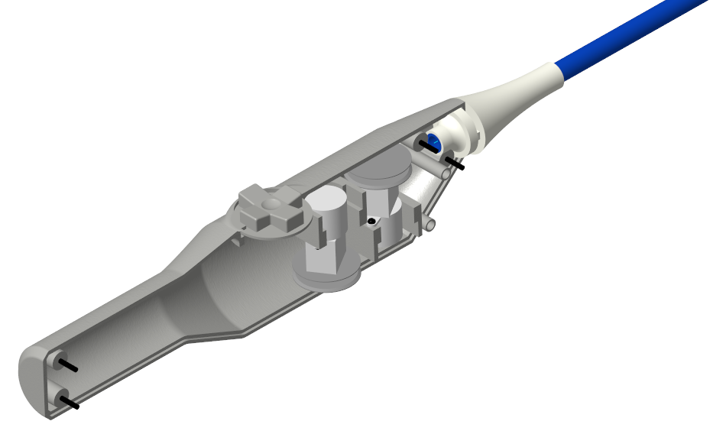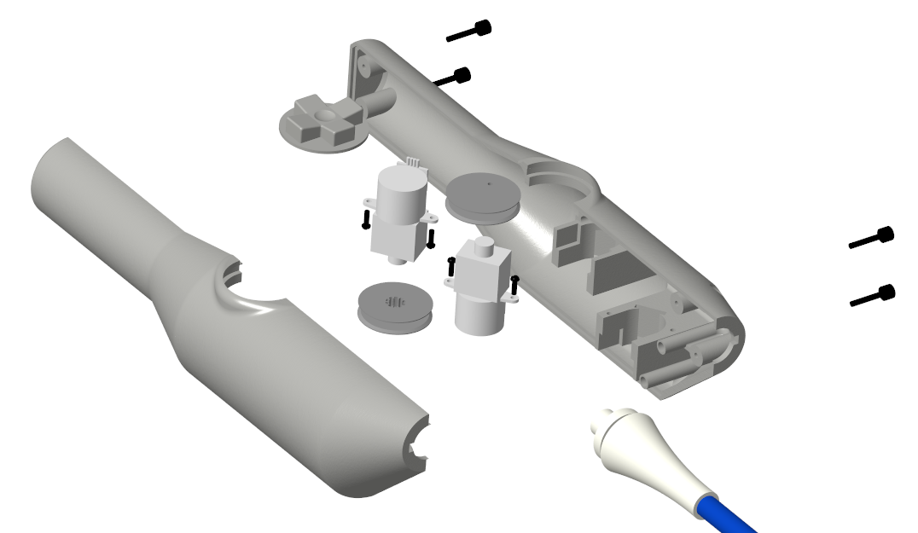

Figure 6): (Left) Inside view of left side of handle; (Right) Exploded view of final design.

The handle was designed to be made in two complimenting halves. This is to make the manufacturing process streamlined and able to be executed. In order to place all the components, the left side houses the components and when final sealing of the handle is desired, the right half sets on top of the left and is held together by four screws. Not only do these screws hold the handle halves together, but they keep the two in the correct position along with the d-pad, interlocking edges, strain relief, pegs, and motor mounts. These all work together to hold the handle together in a sturdy and accurate manner. All components can be seen in the exploded view in Figure 6.

**Testing and Results**

Force testing was performed on the first prototype to evaluate the torque of the motor and the necessary force needed to actuate the tip to the desired angle of 180°. These measurements were used along with beam theory equations (Figure 8) to determine the desired spool size for the device [8]. After the desired angle was achieved, additional testing was completed to evaluate the maximum actuation angle with varying input voltages. Increasing the voltage gave additional power allowing the motor to actuate past the desired angle.

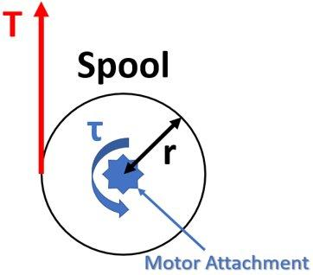 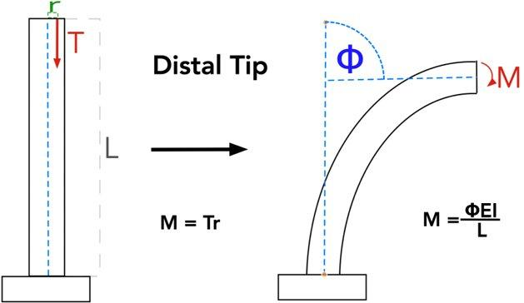

Figure 8: Free body diagrams and equations of the spool and distal tip of the catheter. Note that the tensile force, T, generated by the torque applied by the motor is the same tensile force in the middle image.

After creating a full prototype, additional force testing was going to be completed to evaluate the device’s abilities. Angle testing on the distal tip would have been used to calibrate the angle readout screens on the handle to continuously displace the bend of the tip. This would have been accomplished by taking samples of the motor steps needed to reach specific angles over the range of desired angles. These data points could then be combined into an equation to provide angles for the full span of actuation.

Force testing on the sheath could have been used to calculate when buckling and kinking would occur on the device. Buckling occurs when the stiff section of the device bends under the applied force. This is undesirable because it decreases the actuation angle in the distal tip and applies unnecessary forces to the vasculator along the shaft. Kinking is an extreme form of buckling where a sharp bend forms in the beam due to extreme forces or rotations. These sharp bends damage the catheter and risk injuring the vasculature.

Anatomical models could also have been used to evaluate the catheter’s abilities in vasculature. In operations, many external forces affect the catheter’s motion. These forces are complex to estimate because they vary by procedure, pathway, and patient. Using models provides more realistic conditions for the prototype to be testing under without the need for lengthy calculations. Plans to test the final prototype for several procedural pathways using the university owned vascular models before prototyping was halted.

**Anticipated Regulatory Pathway**

For our device, it is expected to have a class II regulatory pathway in order to pass through FDA guidelines for medical devices. The electronically steerable catheter device is a class II device due to it’s non-invasive properties and that it is not being implanted. Because it would be categorized as a class II device, it would have to undergo the 510(k) premarket notification pathway. In this pathway, it would have to be proved that the new electronically steerable catheter is similar enough to a pre-existing device(s) on the market. According to *Biodesign: The Process of Innovating Medical Technologies*, “the device must be comparable to the predicate device in terms of its intended use, design, energy used or delivered, materials, chemical composition, manufacturing process, performance, safety, effectiveness, labeling, biocompatibility, standards, and other characteristics” [9]. The new device and predicate device can be shown to be substantially equivalent by bench and animal testing [10]. If the two devices can be shown to be equivalent, no premarket approval will be needed and clinical trials will be nonessential. This will change the release time from up to 36 months to as little as three months. Due to it’s characteristics of a class II medical device, it can take the quicker 510(k) pathway.

**Budget and Manufacturing**

Appendix D shows the bill of materials for the prototype created. With a total cost of $85.88, the device’s total cost of goods is much less than the target product cost of $500. With a well designed manufacturing process, the costs can be kept low enough to achieve this goal.

The manufacturing process would follow several steps. The first is constructing the catheter itself. First, the five mandrels, one PTFE for the main lumen and four PTFE stainless steel wires for the pull wire lumens, must be threaded through the two different durometer Pebax extrusions. The distal tip of the catheter has a 2” section of the lower, 35D durometer extrusion. FEP heat shrink is then placed over the joining section and the two durometers are reflowed together. After the heat shrink is removed, the catheter is braided using stainless steel wire. A lower PIC count is used for the stiffer portion, and the tip is braided with a greater PIC count. After braiding, the catheter is then coated with two durometer Pebax jackets, a stiffer one for the long shaft and a softer durometer for the tip. Similar to the first reflow step, FEP heat shrink is put on the catheter, and the entire length is reflowed from the proximal end to the distal tip. Next, a stainless steel hypotube is cut to a length of ¼” which will become the marker band. The PTFE coated pull wires are then laser welded to the marker band. When the reflow process is completed on the catheter, the five mandrels are removed, exposing the five lumens. The pull wires with the marker band laser welded to the end are fed through the four smaller lumens. The last step is another reflow process to cover the markerband with another soft durometer pebax section. This entire process can be scaled up using automated reflow machines that can reflow up to eight catheters at a time, as opposed to just one.

The next step is to make the handle. The handle will be made using an injection molding machine. Once the dies have been made, this process will be cheap and repeatable. The two shells of the handle casing, the d-pad, and the spools that attach to the motors can all be injection molded. After these parts are constructed, the final step is to assemble the parts, including wiring the motors to the computer chip power supply, resulting in the final product.

The materials can be sourced from several different vendors. The Bill of Materials in Appendix D offers a quality vendor for each raw good needed to manufacture the catheter.

**Marketing and Opportunity**

Because this device is a hybrid of two current markets for catheters, it will easily create its own market share thus fulfilling a specific need and being adopted quickly. Due to the affordable price of this device, it is more advantageous than the fully robotic catheter systems that the mid sized hospitals desire and will also provide the smaller sized hospitals with an accurate steerable catheter at a low cost. This allows for the device to be desired and needed amongst hospitals that want an accurate and cost-effective catheter to replace the mechanical steerable catheters. Furthermore, after interviewing the desired customer, cardiac physicians and vascular clinics, there is no device parallel to the electronically steerable catheter. This provides the opportunity for a large market that will readily accept the device, if it functions as planned. In addition, these establishments and users will go to great expense to obtain a device such as this that will provide accurate procedures at a reasonable estimated price of $500. Therefore, the market share for this device is untapped and has the potential to be monumental.

**Further Development and Limitations**

Further work needs to be done to fully complete the physical prototype. Our group created circuits and CAD models, but we did not have the chance to combine all into one handheld device. With more time, we would have 3D printed our handle design and created a PCB for our electronics. These components could then be combined with our manufactured shaft to create a full product design.

More features could be integrated into the current design to add to its function. An increase in the number of wires could give the device multiplanar actuation. By doubling the motors and wires, the d-pad could control motion in four directions: left, right, forward, and backwards. This increased motion would decrease the manual rotation needed to guide the catheter.

In our initial research, surgeons worried about the lack of feedback this device would offer. With mechanical catheters, surgeons can feel through the knobs if the tip is contacting the vasculature, but this feedback is removed when motors are added. Creating an electronic feedback mechanism is a future challenge to prevent accidental rupture of the vasculator.

Finally, the power system of our device could also be redesigned to fit the market needs. Our current system is limited to being plugged in. Future designs could be powered by a battery operated system.

**References**

[1] Benjamin EJ, Muntner P, Alonso A, Bittencourt MS, Callaway CW, Carson AP, et al. Heart disease and stroke statistics—2019 update: a report from the American Heart Association. *Circulation*. 2019;139(10):e56–528.

[2] Lee, K. E., Seo, Y. J., Kim, G. B., An, H. S., Song, Y. H., Kwon, B. S., Noh, C. I. (2016). Complications of Cardiac Catheterization in Structural Heart Disease. *Korean circulation journal*, *46*(2), 246–255. doi:10.4070/kcj.2016.46.2.246

[3] *Japanese Patient No.* 4194691. Japan Patent Office.

[4] West, Scott (1997) Steerable Electrode Catheter *European Patient No. 0 634 941 B1.* London, England. European Patent Office.

[5] Miles, Joseph and MacNamara, Francis (2018) *United States Patent No. 0055589 A1* Washington, D.C. United States Patent Office.

[6] Kirschenman, Mark and Tegg, Troy (2018) *United States Patent No.* *0132950 A1* Washington, D.C. United States Patent Office.

[7] Healthcare-in-Europe.com, Magellan is quick and good for complex ops. (2012). Retrieved from https://healthcare-in-europe.com/en/news/magellan-is-quick-good-for-complex-ops.html

[8] Khoshnam, M., Azizian, M., & Patel, R. V. (n.d.). Modeling of a Steerable Catheter Based on Beam Theory. *2012 IEEE International Conference on Robotics and Automation*.

[9] Yock, P. G., Zenios, S. A., Makower, J., Brinton, T. J., Kumar, U. N., Watkins, F. T. J., … Kurihara, C. (2015). *Biodesign: the process of innovating medical technologies* (2nd ed.). Cambridge: Cambridge University Press.

[10] U.S. Food and Drug Administration . (n.d.). Product Classification. Retrieved April 28, 2020, from https://www.accessdata.fda.gov/scripts/cdrh/cfdocs/cfpcd/classification.cfm?ID=979

**Appendices**

Appendix A: Needs Statement

Appendix B:Functional Requirements Table

Appendix C: Relevant Standards

Appendix D: Bill of Materials

Appendix E: Failure Mode and Effects Analysis - FMEA

Appendix F: Global, Societal, and Economic Impacts

Appendix G: URL/Video(s) of Prototype

Appendix H: Raw Data

**Appendix A - Needs Statement**

A way to improve the usability and actuation of steerable catheters controlled by surgeons to increase surgical accuracy and decrease procedural time.

**Appendix B- Full Functional Requirements Table**

|  |  |  |  |
| --- | --- | --- | --- |
| **Functional Requirements:** | **Design Parameters:** | **Analysis:** | **References:** |
| Affordable | Total cost less than $500 | Cost of use per year, compared against competitors values and non-electronic catheters. | Catheters on the market |
| Electronically controlled | Arduino, motors, power source to pull tendons | The power source does work on the tendons instead of the user | Mentors |
| One-handed use | Controlled by only one hand. Must be contained in a volume of 2"x2"x7" | Overall consensus from surveys and physicians' opinions | Physicians |
| Contour Catheter to different turns/angles with precision | Multiple axis control, Catheter able to bend as far as 180 degrees. | Measure precision against angles with current designs | Physicians |
| Waterproof | Sealed casing, mechanical input must not have an opening associated with it | Testing according to IPX7 standard. 1 meter underwater for 30 minutes | IP Standards |
| Sterile (or can be covered) | Ability to attach to catheter with cover over it, Ability to sterilize between procedures | Comply with ISO 11737-2:2009 | ISO Standards |

**Appendix C - Relevant Standards**

* ISO 13485 Medical Devices - Quality Management Systems
  + The organization making this device must be able to consistently provide the device up to customers requirements and the requirements of regulatory bodies.
* ISO 14971 Medical Devices. Applications of Risk Management to Medical Devices
  + This standard describes how to analyze, prepare, and control for risks of the device. It helps engineers develop proper protocols to ensure user safety.
* ISO 10993 – Biological Evaluation of Medical Devices
  + Our device interacts with human vasculature, so this standard outlines what testing is needed to ensure safe interactions with human blood and tissues.
* ISO 11135 Sterilization of Health Care Products – Ethylene Oxide
  + Catheters need to adhere to sterilization standards in order to be safe to use in surgeries. This standard outlines the proper methods to sterilize between manufacturing and use with ethylene oxide, a common agent used on catheters.
* ASTM F 1980-16 Standard Guide for Accelerated Aging of Sterile Barrier Systems for Medical Device Packages
  + Our device will need to remain sterile for the full duration of its shelf life. This standard describes proper tests to evaluate the length a device remains sterile in its packaging.
* ISO 10555 Intravascular Catheters – Sterile and Single Use Catheters
  + ISO 10555 describes specific parameters the device needs to adhere to in order to meet the safety guidelines of the industry. These parameters include radio detectability, surface roughness, corrosion resistance, and allowed peak forces

**Appendix D - Bill of Materials**

|  |  |  |  |
| --- | --- | --- | --- |
| **Materials** | **Source** | **Quantity** | **Price** |
| PTFE Mandrel - 5mm diameter | <https://www.zeusinc.com/> | 16” | $5.04 |
| Pebax 5-Lumen Extrusion - 72D | <https://www.zeusinc.com/> | 14” | $5.00 |
| Pebax 5-Lumen Extrusion - 35D | <https://www.zeusinc.com/> | 2” | $5.00 |
| Stainless Steel, PTFE Coated Mandrel Wires- 0.016” | <https://appliedplastics.com/> | 4x24” | $45 - can be reused ~5x  $9.00/catheter |
| Stainless Steel, PTFE Coated Pull Wires - 0.012” | <https://appliedplastics.com/> | 4x24” | $45/catheter |
| FEP Shrink Wrap Expanded ID Min: 0.306”  Recovered ID Max: 0.184”  Recovered Wall: 0.010 | <https://www.zeusinc.com/> | 50” | $6.23 |
| Stainless Steel Braiding Wire 6X1 | <https://www.fwmetals.com/> | 16 bobbins | $22.40  $2.24/catheter |
| 55 g 3D Printing Filament (blue and white) | <https://www.amazon.com/HATCHBOX-3D-Filament-Dimensional-Accuracy/dp/B00J0GPC80> | 2 kg | $40  $1.10/catheter |
| Electric Motor - Micro 15MM Metal Gear Stepper Motor 10 Teeth 5V-12V 2-Phase 4-Wire Mini Precision Reduction Gearbox Stepping Motor Robot Camera | <https://www.aliexpress.com/> | 2 | $5.45 |
| ¼” Stainless Steel Hypodermic tubing | <https://www.mcmaster.com/> | 12” | $8.64  $0.18/catheter |
| 4 Screws M1.6 x 0.35 x 6 | <https://www.mcmaster.com/> | 100 | $13.08  $0.52/catheter |
| 4 Screws M1.6 x 0.35 x 12 | <https://www.mcmaster.com/> | 50 | $14.00  $1.12/catheter |
|  |  | Total | $85.88/catheter |

**Appendix E - FMEA**

|  |  |  |  |  |  |  |  |  |
| --- | --- | --- | --- | --- | --- | --- | --- | --- |
|  | **Severity** | | **Occurrence** | | **Detectability** | |  | |
| **Failure Mode** | **Effects** | **Rating (S)** | **Causes** | **Rating (O)** | **Controls** | **Rating (D)** | **RPN = SxOxD** | **Recommended Action** |
| Loss of waterproofing ability causing leakage in handle | Motor malfunction and potential shock | 10 | Improper sealing of all edges and openings, improper manufacturing | 3 | Leak test | 3 | 90 | Leak testing under pressurized liquid |
| Burr/sharp edge on handle | Cut surgeon and potentially patient | 10 | Improper 3D print or plastic molding, improper manufacturing | 7 | Eye inspection | 1 | 70 | Lightly de-burr and sand all edges and surfaces |
| Detachment of the wires to spools | Relaxation of the distal tip, loss of actuation ability | 6 | Improper manufacturing at attachment site | 2 | Cycle testing | 3 | 36 | Iterate on attachment method and test to find the best solution |
| Detachment of spools to motors | Relaxation of the distal tip, loss of actuation ability | 7 | Wearing down of plastic connection | 1 | Cycle testing before releasing product to market | 3 | 21 | Through testing of the resolution of the injection mold or 3D printer, create an interface between the two parts that has the greatest surface contact to decrease contact stress that leads to wear |
| Detachment of wires to marker band | Loss of actuation ability | 6 | Less experience in laser welding leads to poor welds | 2 | Inspection under microscope in laser welding machine and force testing for each wire | 6 | 72 | Develop process for specific wires and marker bands used to ensure consistent and reliable welds |
| Electrical failures | Possible shock to patient or surgeon. Loss of movement | 10 | Poor electronic connections | 3 | Testing the connection points of wires | 7 | 210 | Print as much of the circuitry on a PCB as possible, minimizing the number of wires and connections |
| Misalignment of wires within the handle | Catheter does not actuate in the appropriate direction | 7 | Wire threading through the lumen(s) isn’t aligned during the manufacturing process | 3 | Meeting manufacturing inspection criteria | 4 | 84 | Allow for rework to maintain process yield. Keep wiring loose around spools until correct actuation is ensured in multiple directions |
| Kinking of catheter at change in durometer (stiffness) region or tip | Catheter not steerable properly. Can lead to damage to walls of arteries/veins | 10 | Poor reflow in areas connecting different durometers and too much pull force | 6 | Force testing to determine maximum force needed to kink the catheter and govern the motors to not be able to generate that amount of force | 2 | 120 | Increase number of reflows/changes of durometer to decrease sudden changes in stiffness |
| Steel braiding being exposed | Damage to walls of arteries/veins Can cause serious complications to surgery | 10 | Poor reflow technique leading to exposed braids when wires are pulled | 3 | Visual inspection | 2 | 60 | Better training of manufacturing workers |
| Detachment of catheter to handle | Loss of actuation function, loss of sterility and waterproof ability | 10 | Poor adhesive | 1 | Visual inspection | 1 | 10 | Design the attachment with the chosen adhesive in mind (materials used, surface finish) to ensure solid bond |

**Justification**

For a medical device that is used in a clinical setting, prioritizing patient outcomes is of the utmost importance. With that being said, airing on the side of caution is the standpoint our group sided with. If we felt the failure mode specified could harm the patient in any way, shape, or form, a higher severity was granted to alleviate liability issues. Therefore this produced several failure modes with a higher severity resulting in more than half of the failure modes having a severity of ten. The underlying theme from this is that the product can induce great harm to a patient or user. Consequently more precautions are needed to be taken in the design and manufacturing of this product to limit failures. Because of this, actions should be taken for the occurrence and detectability ratings to be decreased in order to minimize the likelihood of severe failures.

One example of a low risk failure with a high severity rating was the detachment of the catheter to the handle. Even with a catastrophic severity rating, it had our lowest RPN due to it being very infrequent and also highly detectable. The failure mode with the highest RPN was an electrical failure. Although it is all encompassing, some of the consequences of the failure could injure the operator or the patient, causing the severity to be a ten. Not only is it potentially damaging to the people involved, it also could be difficult to detect the severity of the damage, leading to a score of seven in the detectability category. Multiplying the three ratings gives a high score of 210 as an RPN.

**Appendix F - Global, Societal, and Economic Impacts**

Now, more than ever, society is experiencing the value of the healthcare industry. Hospitals globally are becoming flooded with people, reaching max capacity amid the COVID-19 outbreak. There are many working on the front line to help combat and alleviate this ongoing issue. However, there is a cost to this, as hospitals have suspended elective procedures. For many in the medical device space, this is problematic as they rely on their medical devices to be utilized for minimally invasive operations. In our case, this is very applicable. Whether it be for ablation, transcatheter aortic valve replacement, or mitral procedures, catheters have increasingly become utilized for minimally invasive operations today.

As the population continues to age and the risk for cardiovascular and pulmonary disease continues to grow, the advantages and simplicities regarding minimally invasive operations make it a desired option in a clinical setting to treat these complications. These procedures offer benefits ranging from faster recovery time for the patient, shorter hospital stay, increased surgical precision in regards to the surgeon, decreased procedural time, and smaller incisions/scarring in the manipulated area for the patient. This is what minimally invasive operations can offer, making them a safe and reliable choice. Patient care and improving patient outcomes is the most important pillar for healthcare professionals and an emphasis the team understands, so operating with care towards not only the patient, but easing the procedural process for the surgeon as well, needs to be prioritized.

As elective procedures continue to make their way back into the field, many medical device companies can expect to see a growth in revenue after a rough first quarter. Many companies rely on their elective procedure devices to drive revenue, however, with the suspension of elective procedures, this puts a pause on that, forcing companies to make decisions regarding other aspects of their business. This can include cutting employees or reducing salaries to compromise for the pause in procedures.

The simplicity and ease for not only the patient, but the surgeon, coupled with the economic impact and driving force devices play for these companies illustrates the importance minimally invasive operations have for medical device companies. More importantly, improving patient outcomes can be achieved in this way making it a very desirable option.

**Appendix G - URLs of videos of prototypes**

End of Semester Prototype: <https://youtu.be/oyoUe0qiXkg>

This is our prototype at the end of first semester. The focus was on the actuation of

the catheter tip and the electronics behind this motion.

Final Catheter: <https://youtu.be/1kUyojScA_8>

The handle is not the final handle, but the blue steerable catheter is part of the final product. The beginning of second semester was producing a working catheter shaft and handle.

**Appendix H - Raw Data**

First Prototype Force Calculations (12/10/2019):

Force needed to reach 90°: 16.9 N

Force pulled by wire with current spool: 6 N

Need to decrease radius by factor of: 16.9/6 ≈ 3

Final Prototype Force Calculations (03/05/2020):

Force needed to reach 90°: 21.1 N

Force needed to reach 110°: 24.3 N